API GW Node start-stop

**Users**:

1. Cloud Linux user: opc. User opc is sudoer
   1. Connect to cloud with private key to Bastion server and then ssh to API GW node
   2. No need to define other users because API GW is the only application installed.
2. On-premise Linux user: weblogic.

**Install paths**:

1. Install folder /home/opc/api_gw_install
2. Runtime folder /home/opc/api_gw

**API GW Node admin User**

1. API GW node admin user: weblogic / welcome1

**API GW Status/Stop/Start**

1. It is required to enter user & password in any of the commands
   1. 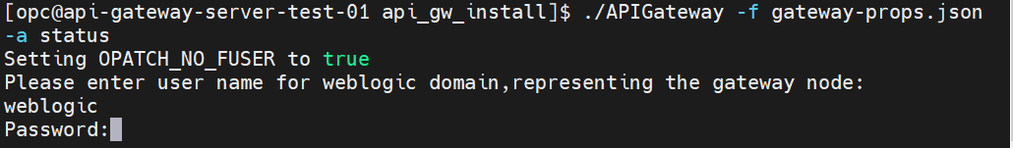
2. For all commands. in the server: $ cd /home/opc/api_gw_install
3. Status check: $ ./APIGateway -f gateway-props.json -a status
   1. If all is well, the response will be:  
      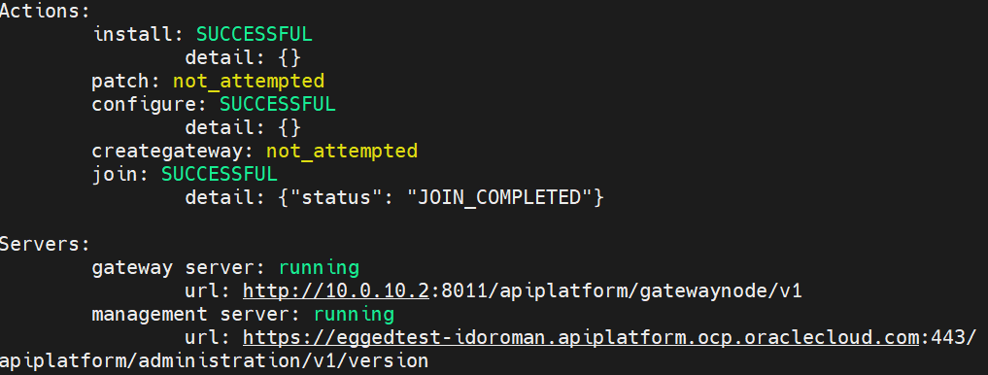
4. Stop API GW node: $ ./APIGateway -f gateway-props.json -a stop
   1. Wait until the Linux prompt is back: $
   2. 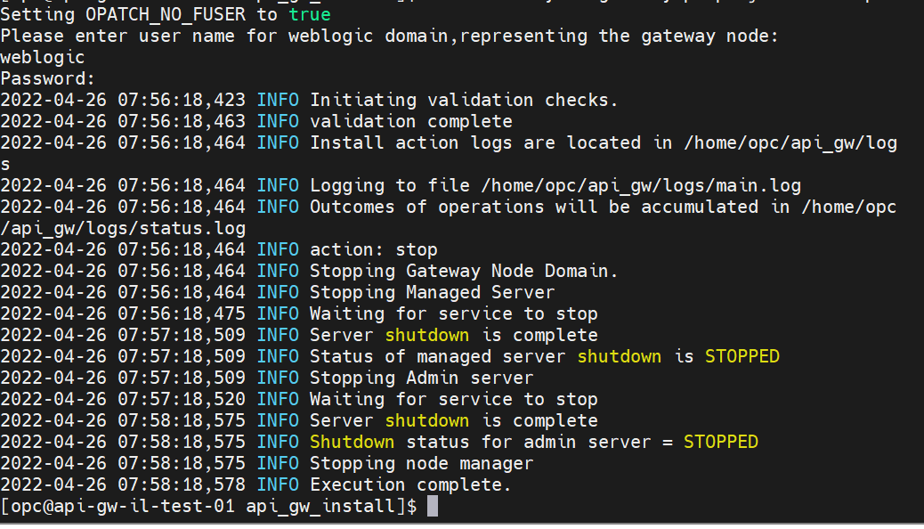
5. If you want to reboot the Linux server, now is the time
6. Start API GW node: $ ./APIGateway -f gateway-props.json -a start
   1. Wait until the Linux prompt is back: $
   2. 